WEEK 2 TASK
Dashboard Planning and Design Strategy
Retail Store Sales & Performance Dashboard

Internship Project – Week 2
Tool: Tableau Public
Dataset: Retail Store Transactions
Prepared By: NAMYA PRUTHI
Date: September 2026

1. Executive Summary
This Week 2 project develops a comprehensive blueprint for an interactive Tableau dashboard based on the Retail Store Transactions analysis completed in Week 1. The design translates the earlier exploratory findings into a planned user experience: users first see high-level KPIs, then examine the time trend, compare products and locations, review payment contribution, and finally investigate selected areas through filters and interactive actions.
The strategy emphasizes a clear visual hierarchy, purposeful chart selection, limited and consistent use of color, and interactions that answer specific business questions. A wireframe and user-flow diagram are included so that the plan can be implemented systematically in Tableau in a subsequent stage.

2. Project Objective
The objective is to design an interactive dashboard that communicates retail sales performance clearly to non-technical and analytical users. The dashboard should reduce the need to inspect raw transaction records by presenting the most important measures and comparisons in a structured visual story.
- Summarize overall retail performance through four KPIs.
- Show how sales change over time using a chronological Year-Month trend.
- Compare sales performance across products and store locations.
- Show sales contribution by payment method.
- Compare quantity sold across products.
- Provide supporting paths for outlier and relationship investigation.

3. Target Audience and User Needs
Audience | Primary Need | Dashboard Response
Store Managers | Quickly compare store and product performance. | KPIs, location comparison, product sales, filters.
Sales / Business Managers | Understand sales patterns and contribution. | Trend, product/location charts, payment mix.
Business Analysts | Explore patterns and investigate questions. | Filters, tooltips, selection actions, supporting analysis.
Primary user: a store or business manager who needs a concise performance overview first and deeper exploration second.

4. Week 1 Findings Driving the Design
Finding | Evidence from Week 1 | Design Decision
Product performance | Monitor generated the highest product sales. | Prioritize Sales by Product.
Location performance | Store C generated the highest location sales. | Include Sales by Location.
Quantity performance | Printer had the highest quantity sold. | Include Quantity Sold by Product.
Payment contribution | Payment methods contributed different sales values. | Include Payment Mix.
Time pattern | Sales varied across months. | Use Year-Month Sales Trend.
Potential outliers | 32 transactions exceeded the calculated upper threshold. | Keep outlier analysis as a supporting view.
Variable relationship | Unit Price vs Quantity correlation was near zero. | Keep scatter analysis as supporting analysis.
Note: the 2025 annual total is partial (January–June), so full-year comparisons with 2023 and 2024 should be avoided.

5. Key Business Questions
- What is the overall sales performance?
- Which products generate the highest sales?
- Which store/location generates the highest sales?
- How does sales performance change over time?
- Which products have the highest quantity sold?
- How are sales distributed across payment methods?
- Which filtered combinations deserve further investigation?

6. KPI Strategy
KPI | Week 1 Baseline | Why It Matters | Interaction
Total Sales | ₹2,207,643.55 | Overall commercial performance. | Updates with filters.
Total Transactions | 2,000 | Transaction volume. | Updates with filters.
Total Quantity Sold | 11,057 | Operational sales volume. | Updates with filters.
Average Transaction Value | ₹1,103.82 | Average value generated per transaction. | Updates with filters.
Placement: all four KPI cards will appear directly beneath the title so users can understand the overall scale of activity before reading detailed charts.

7. Planned Visualizations and Rationale
Element | Type | Question Answered | Why Selected
Year-Month Sales Trend | Line chart | How do sales change over time? | Best suited to chronological movement and peaks/declines.
Sales by Product | Horizontal bar | Which products perform best? | Makes category ranking easy to compare.
Sales by Location | Bar chart | Which store performs best? | Provides direct store-to-store comparison.
Payment Mix | Donut / pie | How is sales value distributed by payment method? | Compact part-to-whole view.
Quantity by Product | Bar chart | Which products sell the most units? | Direct comparison of quantities.
Transaction Value Outliers | Box plot / support | Which transactions may need investigation? | Shows distribution and unusual values without overcrowding the main view.
Unit Price vs Quantity | Scatter / support | Is there a clear relationship? | Appropriate for two numerical variables.

8. Dashboard Information Hierarchy
The planned hierarchy follows the user's likely decision path:
- Level 1 — Overview: title and four KPIs.
- Level 2 — Trend: chronological Year-Month Sales Trend.
- Level 3 — Comparison: product and location performance.
- Level 4 — Composition and volume: payment mix and quantity sold.
- Level 5 — Investigation: filters, tooltips, selections, and supporting analyses.
This structure prevents the dashboard from becoming a collection of unrelated charts and guides the user from broad understanding to focused investigation.

9. Dashboard Layout Strategy
Zone | Planned Content | Design Principle
Header | Title + short subtitle | Immediate orientation.
KPI row | 4 KPI cards | Fast summary.
Main visual area | Year-Month Sales Trend + filter panel | Trend is the main story; filters remain accessible.
Comparison row | Sales by Product + Sales by Location + Payment Mix | Balanced categorical and composition analysis.
Supporting row | Quantity by Product + interaction/tooltips area | Adds operational context without competing with the main trend.
Supporting analysis | Outlier and Unit Price vs Quantity views | Available for deeper analysis rather than primary focus.

10. Professional Dashboard Wireframe
The following wireframe is the proposed blueprint for the future Tableau implementation. It is intentionally schematic it defines hierarchy, placement, and interaction areas rather than pretending to be the finished dashboard.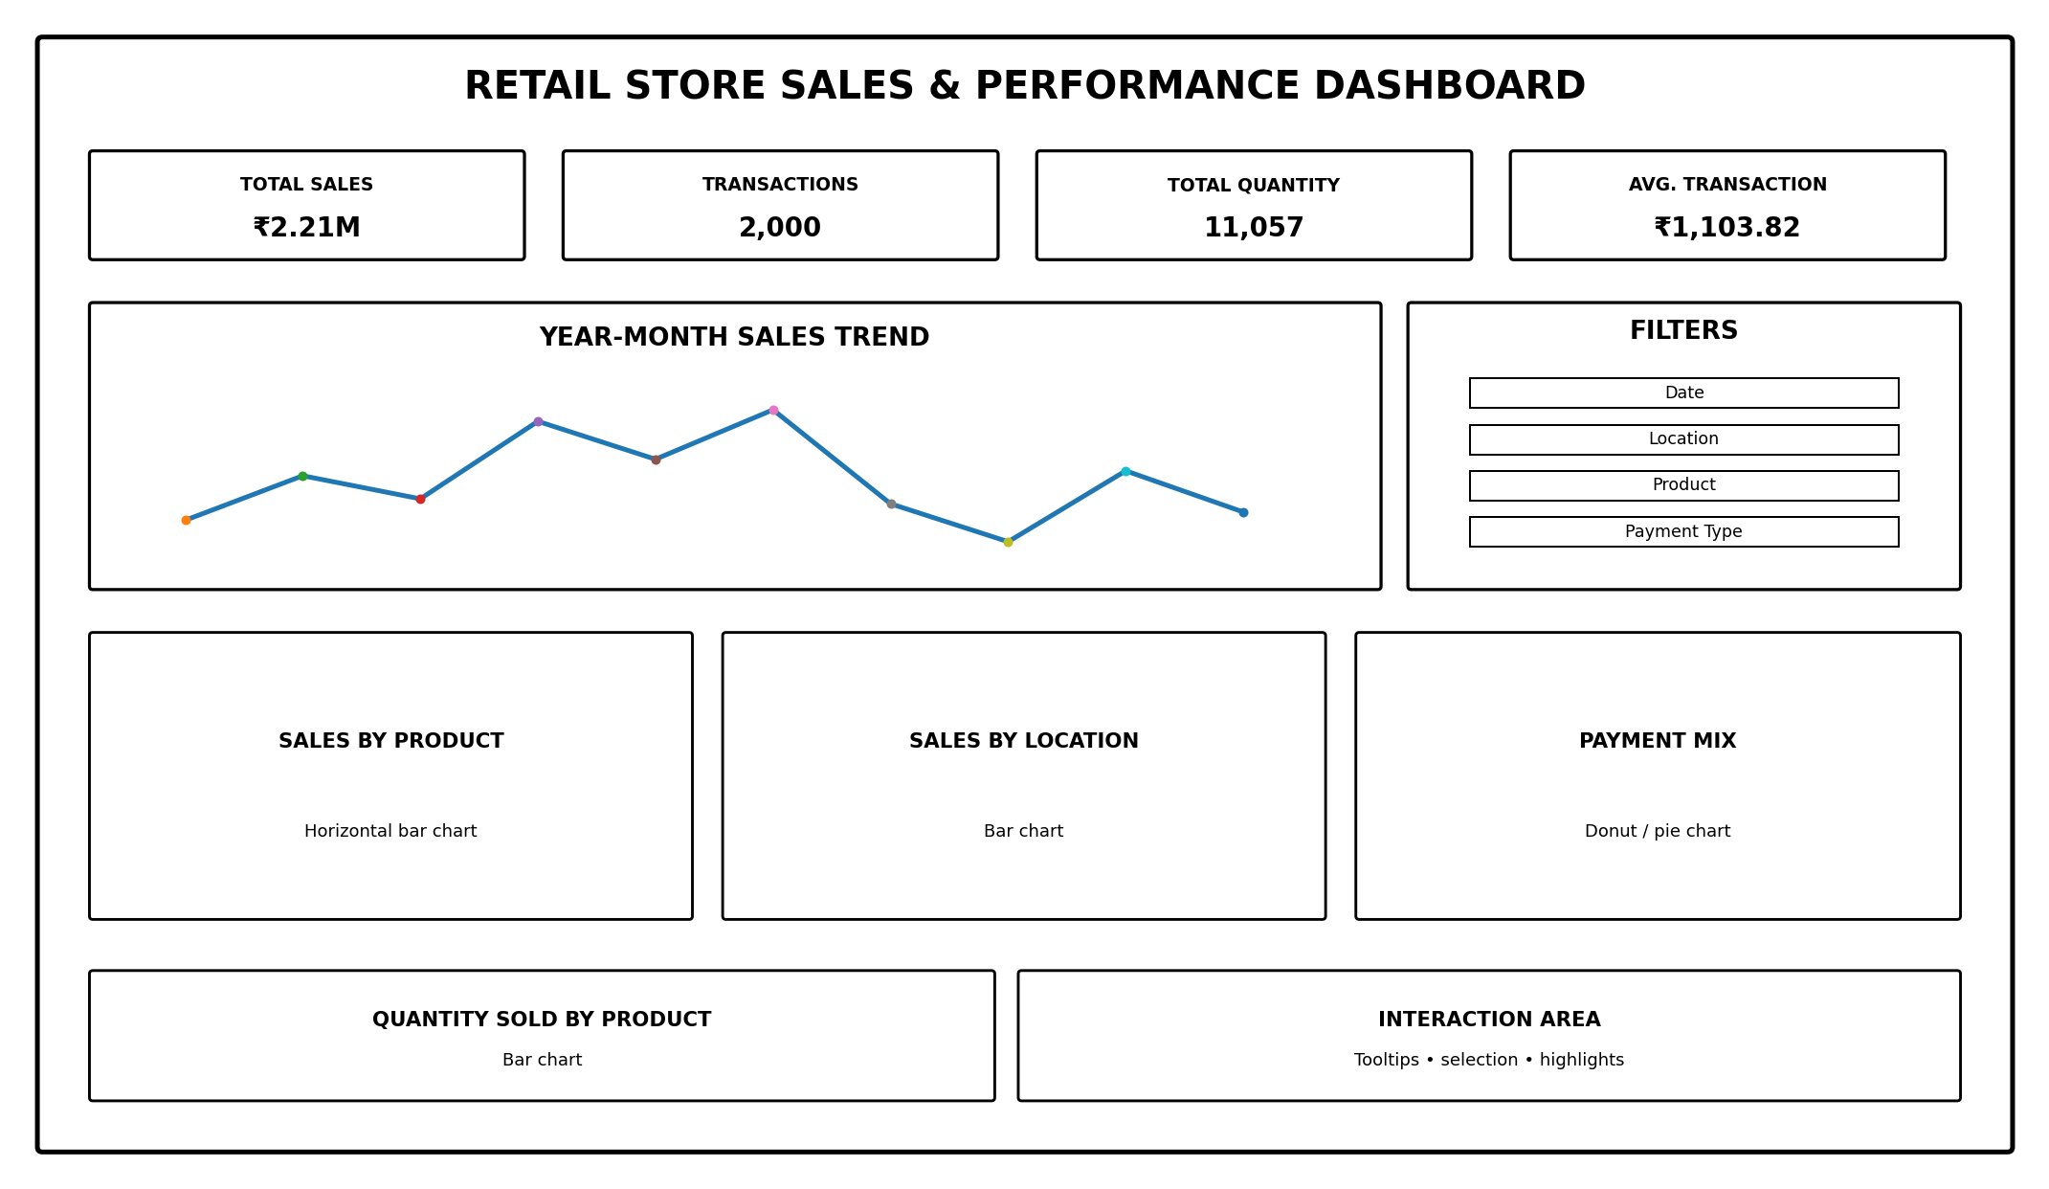

11. Color, Typography and Visual Design Strategy
- Background: white or very light neutral to maximize readability.
- Primary structural color: dark blue for headings, section structure, and selected emphasis.
- Secondary accent: teal for supporting highlights.
- Accent usage: limited to selected states or important findings so the dashboard does not become visually noisy.
- Typography: one consistent sans-serif font family with clear size differences between title, KPI value, chart title, and supporting text.
- Number formatting: Indian Rupee (₹) for monetary values; comma-separated whole numbers for transaction and quantity counts.
- Spacing: consistent margins and breathing room between KPI cards and charts.
- Labels: concise titles that state the business measure rather than technical field names.

12. Interaction and Filter Strategy
Interaction | Planned Behavior | User Benefit
Date filter | Restrict analysis to a selected period. | Focus on a relevant time window.
Location filter | Select Store A–D. | Compare or isolate store performance.
Product filter | Select one or more products. | Investigate product-specific performance.
Payment filter | Select payment method. | Study payment-specific contribution.
Chart selection | Click a product or location to highlight/filter related views where appropriate. | Connect related visual elements.
Tooltips | Show sales, quantity, share, and category details on hover. | Get detail without adding clutter.
Interaction principle: every interactive element should answer a meaningful question; unnecessary animation or decorative interactions will be avoided.

13. User Interaction Flow
The planned user journey moves from summary to exploration and then to investigation.
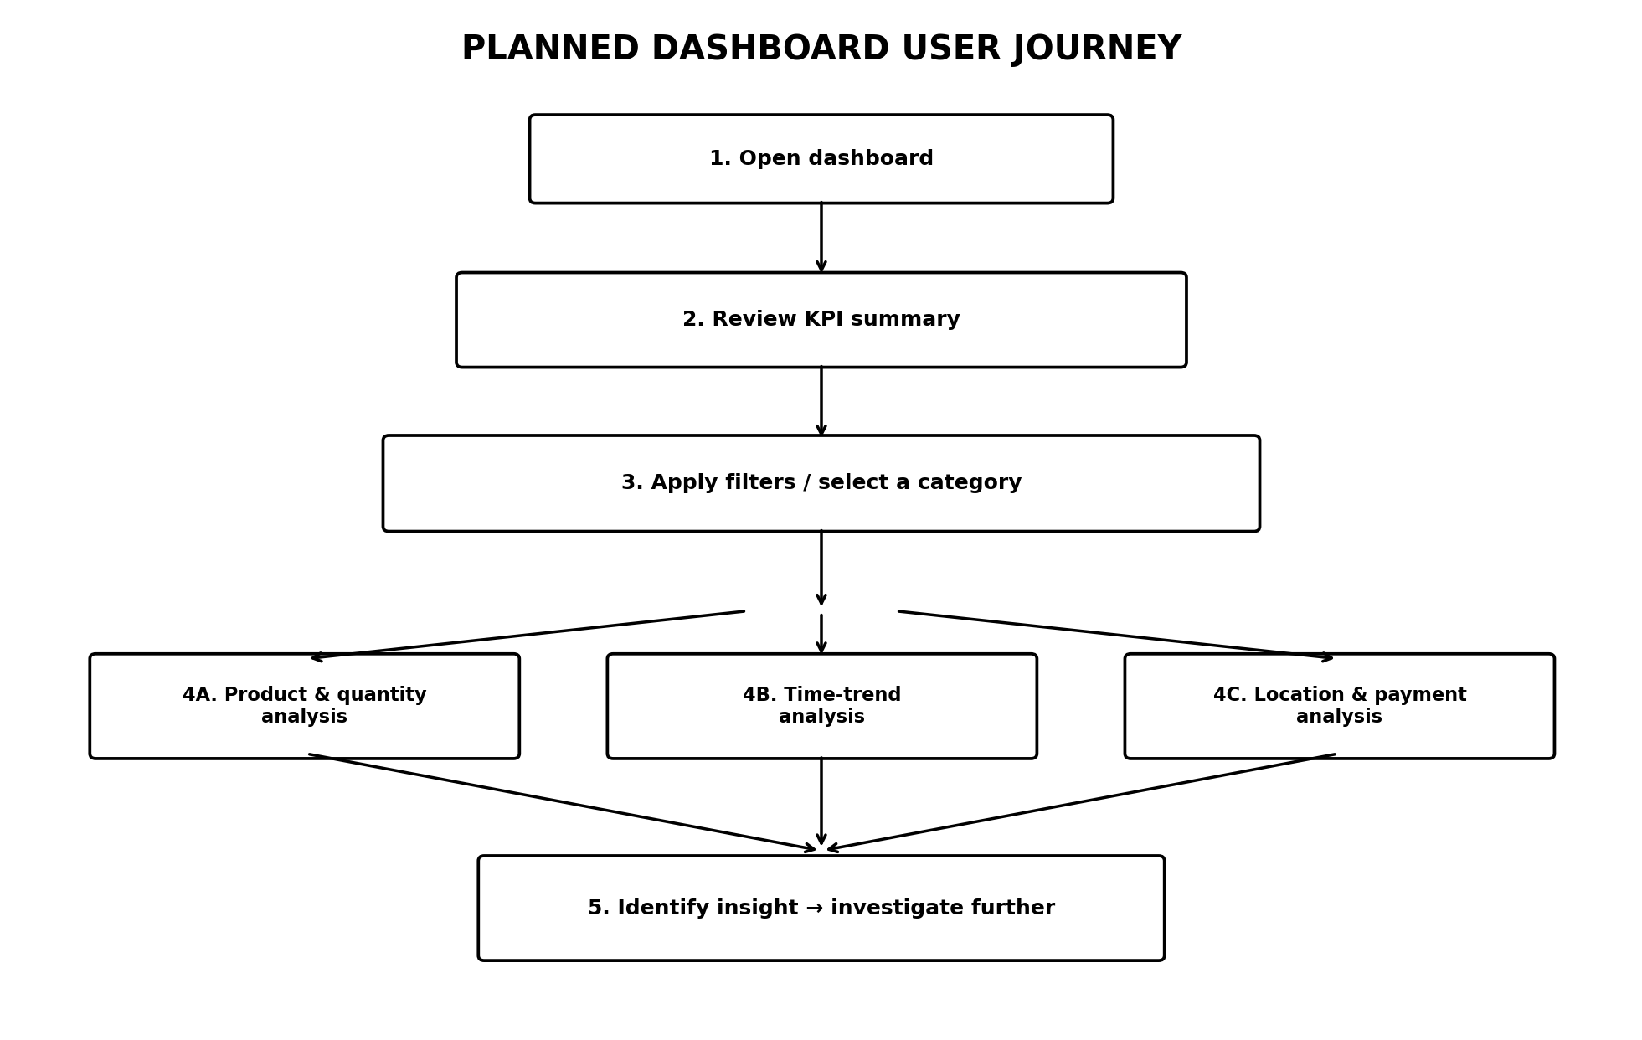

14. Integration Rationale
The dashboard components are intentionally connected. The KPI cards establish the overall scale of activity. The Year-Month trend then provides temporal context. Product and location views answer comparison questions, while payment mix adds another transaction dimension. Quantity by product provides volume context that can be read alongside sales value.
Filters and selections are planned to connect these views. For example, selecting Store C should allow the user to investigate its product performance and payment contribution. Selecting a product should similarly support focused exploration. This creates a coherent analytical path rather than five unrelated charts.

15. Supporting Analytical Views
Supporting View | Role | Why It Is Not a Primary Dashboard Element
Transaction Value Outliers | Investigate potentially unusual high-value transactions. | Useful for deeper analysis but can distract from the main business story.
Unit Price vs Quantity | Explore the relationship between two numerical variables. | Useful for analysis, but the relationship was weak and is less central to the dashboard objective.
The outlier analysis identified 32 transactions above the calculated upper threshold of ₹3,554.95. The maximum transaction was ₹3,997.40. These observations should be treated as potentially unusual transactions for investigation, not automatically as errors.

16. Expected User Experience
- The dashboard should be understandable within the first few seconds through the KPI row.
- The main trend should establish the overall time-based story before detailed comparisons.
- Users should be able to answer common product and store questions without opening the raw data.
- Filters should make the dashboard useful for focused questions without changing its overall structure.
- Tooltips should provide additional detail without overcrowding the visual canvas.
- Supporting analysis should be available when deeper investigation is needed.

17. Future Tableau Implementation Plan
- Connect the cleaned Retail Store Transactions dataset to Tableau Public.
- Confirm data types and calculated fields such as Total Price and Year Month.
- Build the four KPI cards.
- Create the Year-Month Sales Trend.
- Create Sales by Product, Sales by Location, Payment Mix, and Quantity by Product.
- Add filters and interactive actions.
- Assemble the dashboard according to the wireframe.
- Apply the planned color, typography, spacing, and number-format strategy.
- Test filtering, selections, tooltips, and dashboard readability.
- Validate that the final dashboard answers the defined business questions.
- Publish and document the final Tableau dashboard in the subsequent implementation stage.

18. Evaluation Alignment
Evaluation Criterion | How This Plan Addresses It
Detailed approach and clarity | Defines objectives, audience, business questions, KPIs, visual hierarchy, interactions, and implementation steps.
Quality and creativity of layout planning | Uses a structured information hierarchy and a professional dashboard wireframe.
Effective use of diagrams/mock-ups | Includes a dashboard wireframe and a user interaction-flow diagram.
Depth of reasoning | Explains why each chart is selected and how the elements work together.
Blueprint for later implementation | Provides positions, interactions, filters, measures, and a step-by-step implementation plan.

19. Limitations and Assumptions
- The plan is based on the Retail Store Transactions data used for Week 1.
- The data covers January 2023 to June 2025; 2025 is a partial year.
- Total Price is derived from Quantity × Unit Price, so relationships involving Total Price require careful interpretation.
- Outliers are treated as potentially unusual observations requiring investigation rather than automatic data errors.
- The final Tableau implementation may require small technical adjustments after interaction testing.

20. Conclusion
This Week 2 planning exercise converts the Week 1 exploratory findings into a systematic blueprint for an interactive Tableau dashboard. The design prioritizes clear business questions, a focused KPI layer, appropriate visualization choices, consistent visual language, and purposeful interactions.
The wireframe and user-flow diagram provide a practical foundation for the next stage of implementation. Each major dashboard element has a defined purpose, a planned position, an interaction strategy, and a connection to a business question. This approach is intended to make the eventual Tableau dashboard both visually clear and analytically useful.

